***Section* 3.8 – Taylor and Maclaurin Series**

The sum of a power series:













In general: 

If  has a series representation, then the series must be



**Taylor and Maclaurin Series**

***Definitions***

Let  be a function with derivatives of all orders throughout some interval containing ***a*** as an interior point. Then the ***Taylor series generated by***  at  is



The ***Maclaurin series generated by***  is



The Taylor series generated by  at .

***Example***

Find the Taylor series generated by . Where, if anywhere, does the series converges to .

***Solution***

 

 

 

 

 

 

The Taylor series is:





***Taylor* Polynomials**

***Definition***

Let  be a function with derivatives of order *k* for  in some interval containing *a* as an interior point. Then for any integer n from 0 through *N*, the Taylor polynomial of order *n* generated by  at  is the polynomial



***Example***

Find the Taylor series and the Taylor polynomials generated by  at 

***Solution***









This is also the Maclaurin series of 

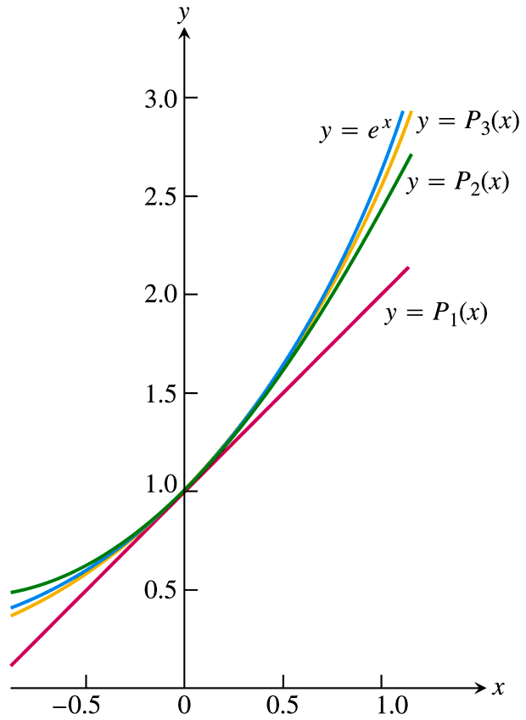

The Taylor polynomial of order *n* at *x* = 0 is



***Example***

Find the Taylor series and the Taylor polynomials generated by  at 

***Solution***





The Taylor series generated by  at  is











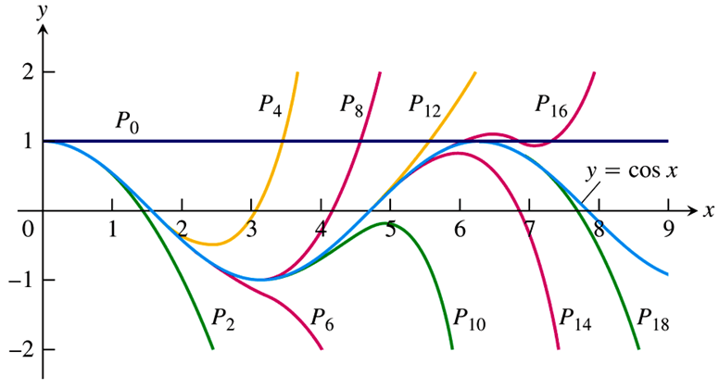

***Example***

Find the Taylor series for  about . Where is the series valid?

***Solution***









This series representation is valid for all *x*.

***Example***

Find the Taylor series for  in powers of . Where does the series converge to ?

***Solution***

Let , then







 

 

 

 

 















Since the series for  is valid for , this series for  is valid for 



***Exercises Section* 3.8 – Taylor and Maclaurin Series**

(**1 − 23**) Find the Taylor polynomials of orders 0, 1, 2, and 3 generated by 

|  |  |
| --- | --- |
|  |  |

(**25 − 35**) Find the *n*th Maclaurin polynomial for the function

|  |  |
| --- | --- |
|  |  |

(**36 − 39**) Find out the ***third*** term of the Maclaurin series for the following function.

|  |  |
| --- | --- |
|  |  |

(**40 − 55)** Find the Maclaurin series for

|  |  |  |
| --- | --- | --- |
|  |  |  |

(**56 − 59**) Finding Taylor and Maclaurin Series generated by 

|  |  |
| --- | --- |
|  |  |

(**60 − 68**) Find the Taylor series of the functions, where is each series representation valid?

|  |  |
| --- | --- |
|  |  |

(**69 − 81**) Find the *n*th−order Taylor polynomial centered at *c* for the function

|  |  |
| --- | --- |
|  |  |

(**82 − 84**) Find the sums of the series

1. 
2. 
3. 

(**85 − 90**) Use the geometric series , for , to determine the Maclaurin series and the interval of convergence for the following functions.

|  |  |
| --- | --- |
|  |  |

1. The limit  that is the relative error in the approximation 

Approaches zero as *n* increases. That is *n*! grows at a rate comparable to . This result, known as Stirling’s Formula, is often very useful in applied mathemmatics and statistics. Prove it by carrying out the following steps.

1. Use the identity  and the increasing nature of ln to show that if ,



And hence that 

1. If , show that





1. Use the Maclaurin series for  to show that





and therefore that  is decreasing and  is increasing. Hence conclude that  exists, and that



1. Suppose you want to approximate  to within  of the exact value.
2. Use a Taylor polynomial for  centered at 0.
3. Use a Taylor polynomial for  centered at 125.
4. Compare the two approaches. Are they equivalent?
5. Consider the function



1. Use the definition of the derivative to show that 
2. Assume the fact that  for *k* = 1, 2, 3, …. (prove using the definition of the derivative.) Write the Taylor series for  centered at 0.
3. Explain why the Taylor series for  does not converge to  for 
4. Teams *A* and *B* go into sudden death overtime after playing to a tie. The teams alternate possession of the ball and the first team to score wins. Each team has a  chance of scoring when it has the ball, with Team *A* having the ball first.
5. The probability that Team *A* ultimately wins is . Evaluate this series.
6. The expected number of rounds (possessions by either team) required for the overtime to end is . Evaluate this series.